

|  |  |  |
| --- | --- | --- |
| **Supervisor** | SIR HARIS | |
| **Batch** | **2302B1** | |
| **Group** | **B** | |
| **Serial No.** | **Enrollment Number** | **Student Name** |
| 1. | Student1453035 | ABUBAKAR |
| 2. | Student1453038 | HAFIZ MUHAMMAD ZEESHAN |
| 3. | Student1431517 | USMAN ALI |
| 4. | Student1452380 | MUHAMMAD ANAS |

1.Home(index.html):

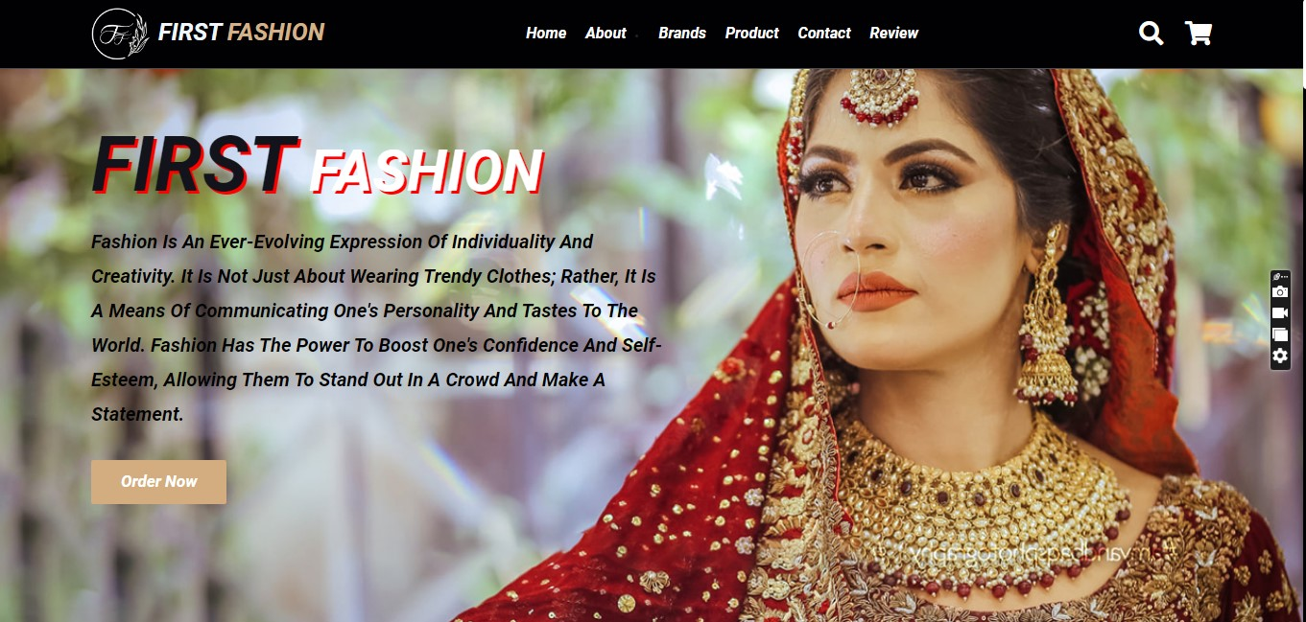

* By clicking the logo, the user will be taken to the homepage.
* Using the navbar, the user can navigate through various categories.

2.Navbar(index.html):



* There are four essentials listed here, and you will be redirected to the pages except for (Brands) and (Product), which are further classified.

3.Add to cart(index.html):

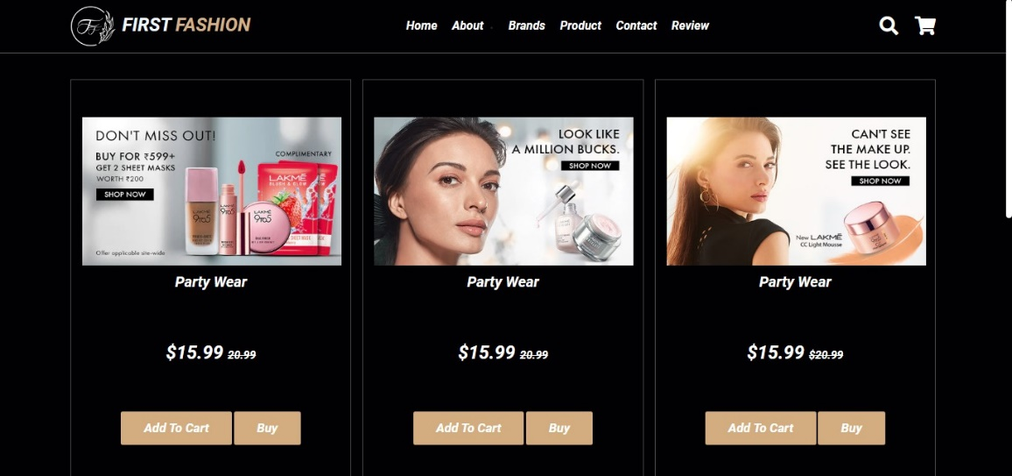

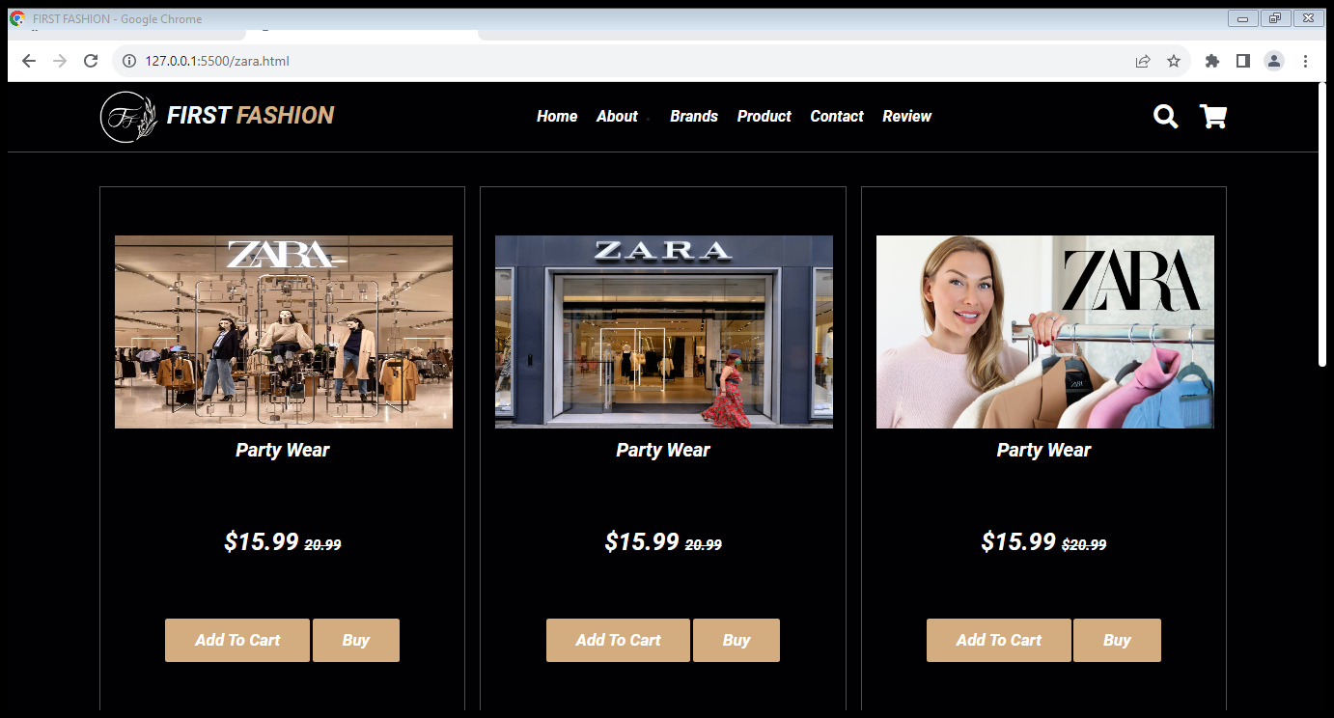

4.About Us(About.html):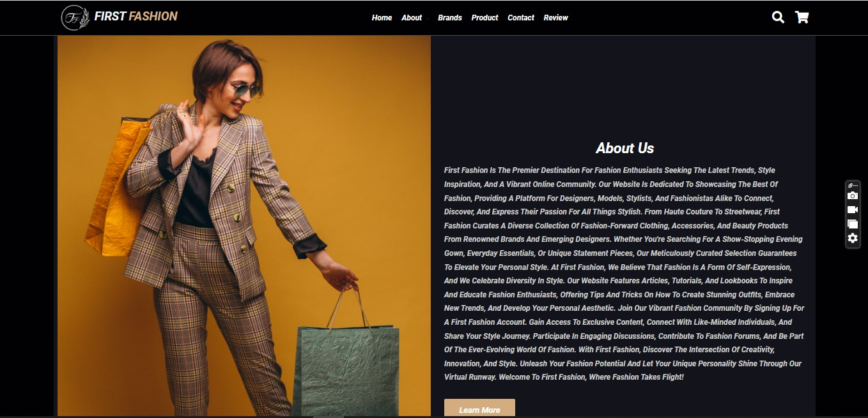

5.Contact Us(ContactUs.html):

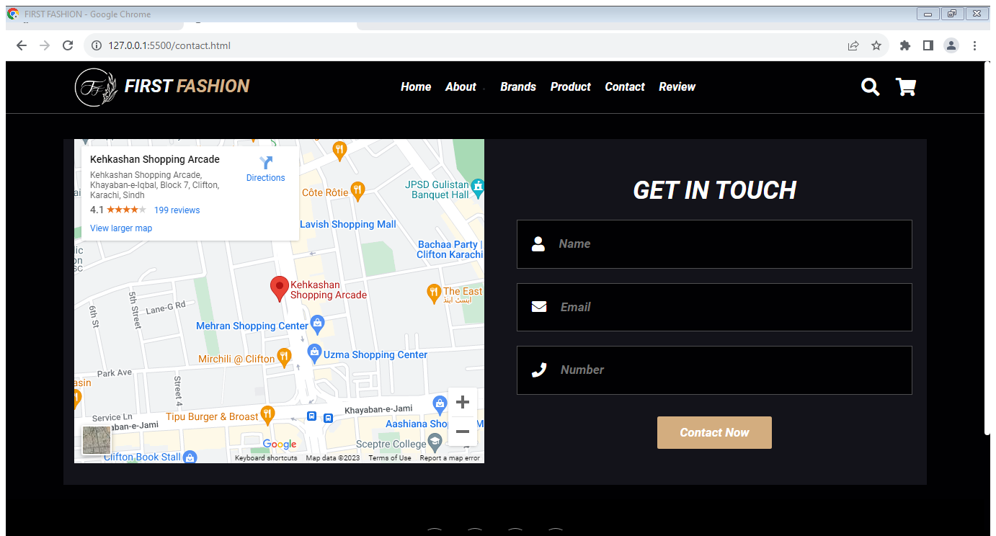

6.Footer:



**7.Summary**

The "First Fashion" User Guide is a comprehensive and user-friendly resource that helps users navigate the world of fashion with style and ease. The guide introduces users to the latest fashion trends, offers seamless website navigation, and emphasizes the importance of mobile-friendly features. It showcases personalized fashion recommendations and enables users to explore captivating fashion collections with interactive features and virtual try-on experiences. The guide also covers effortless e-commerce integration, secure payment options, and encourages users to engage with the fashion community. With this guide, users can enjoy a personalized, enjoyable, and inspiring fashion experience on the "First Fashion" platform.